Owain Mahoney

Matthew Wisden

Pawel Kaczmarczyk

Jake Watkins-Brown

Phase 3 Documentation

Contents

Components/programs/applications used in the project 2

Trello 2

Slack 2

Python 2

C# 2

Messenger (Video chat) 2

PostGres 3

Github 3

# Components/programs/applications used in the project

## Trello

Trello is a web application that our group used for organisational purposes. We used this as a way to set tasks for the project. We followed a method of completing the tasks as were listed on the trello page. The group would contribute toward updating the trello page saying what tasks they have completed. One team member would use this to log hours effectively as | would mean one hour.

The following a screenshot from our trello page

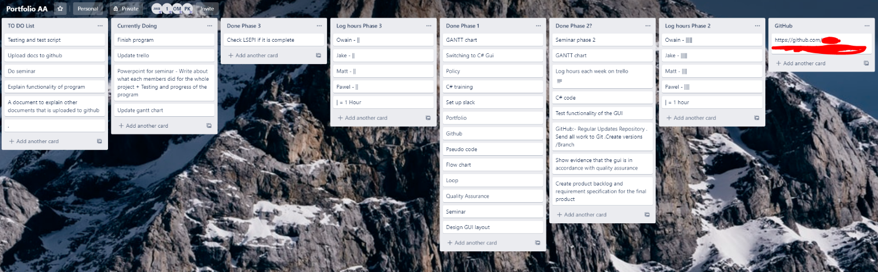

As shown in the screenshot this displays our group tasks, what we are currently doing at this moment in time and what we have already completed. This method enables communication between the team members when they are not available.

## Slack

Slack is an application that our group have used to communicate. We used this application to discuss certain issues or ideas that may come up during the development. This application helped us move forward as a team after discussing ideas and deciding which is the right approach for each issue.

## Python

Originally we were going to do this project using Python, however after our first draft we have realised how difficult and cumbersome it is for this project. So after a discussion we have unanimously agreed to use C#. We didn’t have the training to work on python at the time that would be suitable for the time constraints on our project.

## C#

We used C# to set up the GUI for the program. We have been trained in this in another module. We found C# to be easier to use as it is more GUI friendly and it is quicker to make quick visual corrections. This improves the quality of our program dramatically.

## Messenger (Video chat)

We chose to use messenger to do a group voice/video chat. Again this is another communication technique used for when each member of the team is not available, but they can still be contacted. This was used to discuss ideas mainly.

## PostGres

We used PostGres for database purposes as we have already been trained on this in another module of our course. We found this to be a very convenient tool for the project. It allowed us to store the information that was needed for the payroll system

## Github

We used Github to meet the management requirement for the project. This was used to store the program and to allow users to access it from any machine. We found this to be a very useful tool for this reason also.